Game-Theory-Based Balance: Formalizing the Machine Unlearning Problem as a Game Between Model Provider and Data Provider

PhD Proposal Submitted to

By
Mr. Abhishek Hupele
Reg. No.: 240900465
Computer Scientist (PE), Research and Development - EV
EdgeVerve Systems Limited, An Infosys Company

Under the Supervision of
Dr. Sanjay Singh
Professor (Guide)

Dr. P.C. Siddalingaswamy
Associate Dean (Co-Guide)

Dr. Naveen Kulkarni (Co-Guide)
Director – Product Engineering - AI
EdgeVerve Systems Limited, An Infosys Company

Introduction
With the tremendous technological advancement in Artificial Learning (AI) and Machine Learning (ML) in the last decade, it’s adoption has increased many fold and has infiltrated our life as an integral part of majority of digital services we interact with [1].
Now, if AI and ML are engines driving the technology revolution, Data is its fuel. Popular phrase “Garbage In and Garbage Out”, Accurate and Reliable Data is more so important in this era, which makes this technology meaningful.
Personally Identifiable Information (PII) is a treasure trove, highly relevant and not easily available, which has lead to violations of privacy and personal data is used without consent, which in turn has led people more exposed and vulnerable. Several cases like Cambridge Analytica (2018), Apple Card Gender Bias (2019), Amazon Hiring Algorithm (2018), Clearview AI Facial Recognition (2020), Target Pregnancy Prediction (2012), Cross-Border GenAI Misuse (Predicted by Gartner, 2025) have come into light which violated the PII norms and deviate from Responsible AI principles.
This has led governments worldwide to pass legislations for an individuals “Right to be Forgotten”, there by necessitating large corporations compliance. Notable laws are the GDPR in the European Union [1][2][16], the PIPEDA privacy legislation in Canada [1][2][17], the California Consumer Privacy Act in the United States [1][2][18] and Digital Personal Data Protection Act, 2023 in India [19].
This originated interest and research in Machine Unlearning as prominent discipline. Suppose your data has been used for training, say for example by an Ecommerce company to train their recommendation engine, or your medical history is used by big Pharma industry, or your financial data is used by Credit Card, Insurance, Ecommerce companies, or your geo-location, gender, Facebook, Instagram, email data is used for political election targeting and manipulation. This opens up whole bag of worms for an individual exposing his/her financial, health , and other personal data which can be used to harm the person of interest.
Now, suppose your data has been used with or without your knowledge, or you have unknowingly given consent and at later stage you want to take back your consent, the person should have choice to share data or not, and also option to choose to what extent the data can be used and control over what data is being used. Now, withdrawing consent would trigger deletion of data, but it is not simple as that , suppose your data is being used to train ML models, Deep Learning (DL) models or LLM models , the data can be called truly removed only if the data is removed from such models or its contribution is removed. This whole problem of removing PII data from models falls under Machine Unlearning.
Now, it poses multiple challenges:
First, it is two edge sword , if all or majority of people in the world choose to refrain from allowing any type of their data to be used, than we as a society and individual will not be able to reap benefits of all the technological advancement that can be possible. For example, your medical data can be used to train for disease prediction like cancer or ecommerce recommendation engine helps you to locate desired product from millions of choices by showing relevant results, or may be as a recruiter you get help from AI to shortlist relevant candidates from thousands of applications, these are only few of the examples.
Basically, technology should be used for making your life easier, save your time, do things efficiently which needs data to stay relevant in many cases, so as I said its two edge sword, lack of data will make AI models irrelevant in certain critical scenarios and on the other hand exposing data may harm individually financially , mentally.
So there needs to be balance, and safe guards for data privacy, and choice to the individuals giving control over how and what data of theirs is used.
Secondly, removing the data already used to train complex models like DL, ML and LLMs, is highly difficult for reasons like randomness, catastrophe effect, complex algorithm. And it is not always easy to find the contribution of particular data point.
Third, Guarantee of Removal, if some model provider claims that particular data has been removed, the verification of that claim is also a challenge called certified removal [8][20].
Fourth, there are so many algorithms , scenarios, models in the play and there is no generalized machine unlearning algorithm that fits for all. There are data providers , model providers than there are malicious players which use Membership Inference Attacks (MIA), Jailbreak etc. To give different scenarios like for example: Federated settings there are multiple agents, Feature Based Unlearning, Outcome could be bias.
Fifth, removing data leads to decline in model performance, also the difference in output of old and new unlearned model can be used to obtain information on data [1][2][21].

Literature Review
In the rapidly evolving landscape of artificial intelligence (AI), the concept of Responsible AI has gained importance and due relevance. Responsible AI (RAI) ensures that AI and Machine Learning (ML) applications are developed , deployed and used embodying the RAI principles ensuring ethical , legal norms [22]. Machine Unlearning is one of the techniques which enables achieving RAI principles, it involves selective forgetting of user data, upholding users “right to be forgotten” [1][2]. The naïve approach is train machine learning models from scratch but that consumes lot of time , compute resources and in some cases like LLMs simple not feasible. Broadly classified as data-oriented and model-oriented approaches.
As a solution to naïve approach of training from scratch, SISA training suggested by Bourtoule et al. [20] works on simple concept of dividing the data into shards and selectively training only the shards where data needs to be forgotten, it lacks though in case if uniform removal requests across all shards as it means retraining the all the shards. Cao et al.[23] in one of the first research papers in this area suggested approach of manipulating data by simply updating a small number of summations and using them which is faster than training from scratch.
There are a lot of different scenarios that can come into picture while Machine Unlearning like Centralized Unlearning, Federated (Distributed) Unlearning, Unlearning Verification, Privacy & Security issues in machine unlearning. Further more there is feature unlearning, sequential unlearning, dynamic unlearning, model specific unlearning techniques (llm unlearning, reinforcement unlearning etc.), human-in-the-loop unlearning, streaming data unlearning. Apart from privacy concerns Models might need to unlearning data to remove improper data, obsolete data, noise, non-relevant data etc.
You may also need to do selective unlearning where your goal could be privacy, security , transparency or fairness. By ensure responsible ai norms , trust is developed among users , increasing their willingness to share the data for better model performance.

Research Gaps identified
Many open areas of research exist in this field, like theoretical framework, feature based unlearning, unlearning in foundational models (LLMs), federated unlearning, incentive mechanism , sequential unlearning, game theory based unlearning, verification of unlearning , unlearning in reinforcement, dynamic unlearning for streaming data, human-in-the-loop unlearning.
Game-theory-based balance [1] :
In machine unlearning there are two players, data provider and model provider. Data provider share their data on which model is trainer by model provider, data providers wants security and privacy of their personally identifiable data, transparency on how and where it is used as well as it is used ethically, fairly (responsibly). Data providers may want to minimize data sharing to avoid unnecessary exposure. Model providers on the other hand require more and more data to train their models, so that the model is performant.
Further, there are external agents wanting to exploit loopholes in model training and extract personally identifiable information (PII) from data, this includes membership inference attacks MIA) , reconstruction, attribute inference, poisoning attacks. Machine unlearning can help to mitigate such risks.
Now, here is a need to be a balance between data provider’s and model provider’s requirements to reach an equilibrium stage with acceptable trade-offs. Various strategies can be applied to achieve the same, game theory is disciple of strategies and it becomes relevant for achieving equilibrium state between data provider and model provider factoring external factors like MIA , poisoning, attribute inference etc. Several privacy-preserving techniques have came out whose application needs to be studied in game theory based frameworks for machine unlearning [3].
game theory is a booming field with several privacy preserving technique’s being developed in last decade, can machine unlearning be treated as a game between model provider and data provider ? where we can define set of strategies and utility by which we can achieve a trade-off or equilibrium where model performance is acceptable and also it balances responsible ai concerns around security, fairness, transparency and privacy. Formalized as a game between these two players/entities and defining framework for strategies and utilities to be employed to achieve desired model performance while accounting for user concerns, in and efficient way. Verifiable machine unlearning and understanding (analyzing) the game strategies will also help in devising incentive strategies for users to share there data.

Incentive Mechanism: study strategies on how to deigning a system which incentivizes users to share data as well as preventing misuse of their data and keeping performance good need to be studied. In federated settings which can have multiple users , users should be able to ask for data removal partial or fully without loss in model performance.
Foundational models are complex with billions of parameters, it is difficult to find contributions of data points with certainty, although some work has been done in this area, we would like to explore a game theoretic framework between unlearning performance and privacy modules similar to done in deep learning and multilayer perceptron models [21].
Now, in Machine Unlearning there could be many different attributes like models, dataset, utility, game theory framework’s, harmful agents, various unlearning settings (federated, sequential , dynamic etc.) below diagram shows landscape of potential game theory opportunities to be explored.
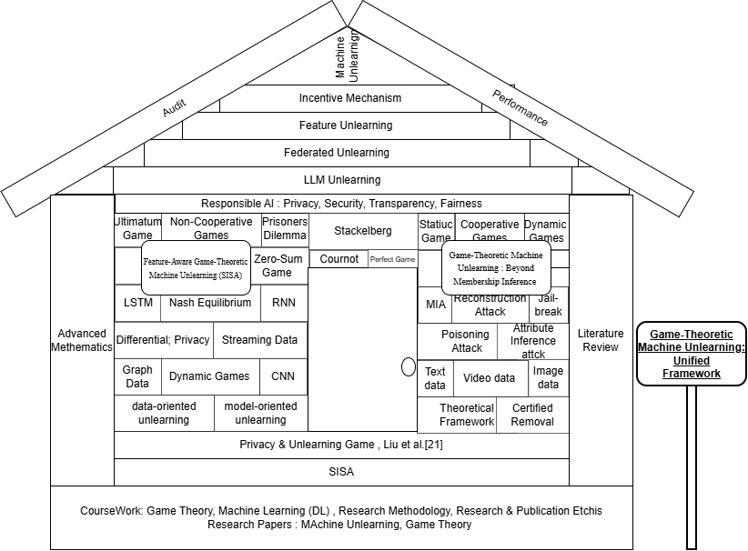
research gaps identified in the field of machine unlearning and game-theoretic approaches:

📌 Research Gaps
- Theoretical Frameworks
Lack of a unified, formalized game-theoretic framework for machine unlearning across diverse models and scenarios.
- Feature-Based Unlearning
Limited exploration of feature-aware strategies (feature extraction, generation, selection) integrated into unlearning operations.
- Foundational Models (LLMs)
Difficulty in applying unlearning to large language models with billions of parameters; contributions of individual data points remain uncertain.
- Federated Unlearning
Need for strategies in distributed/federated settings where multiple agents/users may request partial or full data removal.
- Sequential & Dynamic Unlearning
Insufficient research on unlearning in evolving/streaming data ecosystems and sequential deletion requests.
- Verification of Unlearning
Challenge of certified removal — verifying that data has truly been erased from models.
- Game-Theory-Based Balance
Lack of equilibrium strategies between data providers (privacy, minimal sharing) and model providers (performance, utility).
- Adversarial Threats
Limited integration of broader attack models (membership inference, attribute inference, reconstruction, poisoning) into unlearning frameworks.
- Incentive Mechanisms
Need for systems that incentivize users to share data responsibly while preventing misuse.
- Performance Trade-offs
Decline in model accuracy after unlearning and absence of benchmarks for acceptable trade-offs between privacy and utility.

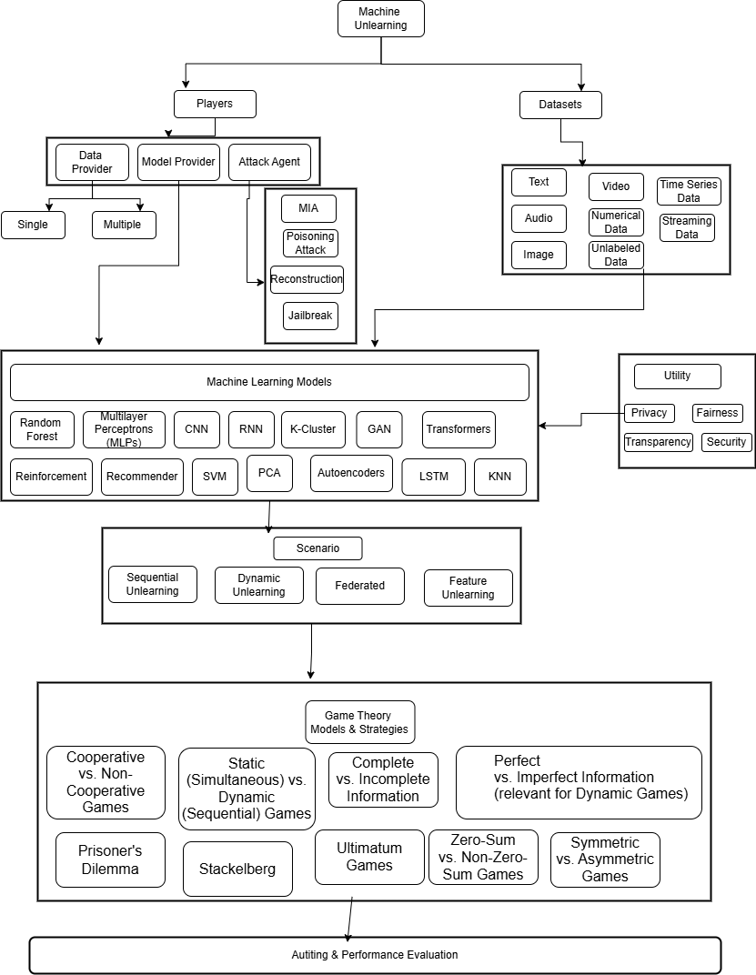

Objectives
Our objective is to reach optimum state of model in efficient way across multiple possibilities, and develop guideline framework for different scenarios and achieve desired equilibrium state or best possible outcome based on constraints.
The task is to develop strategies including multiple agents and based on different models, scenarios or desired outcomes , design game models to achieve balance with usable outcome efficiently, now each task will have multiple options to choose, data provider wants to minimize data sharing, while model provider wants to maximize data collection ideally, but lets work toward a strategy to achieve a balance, there may be some data which is very relevant for the task and some data which may be PII and is not contributing much and so we need a strategy to arrive at those relevant attributes which are needed , also suggest some benchmark on the data and model performance tradeoff – how to arrive at such benchmarks, also using existing verification methods to audit unlearning in our procedure.
Now, as in diagram in Section 3, we see there could be a lot of variations and attributes into play, which makes the study very broad in terms of ground to be covered in limited time, what we propose is identifying most promising areas of research and will begin with those promising areas like feature engineering, extending existing study on game theory[21], llm unlearning or any other topic which is seen or emerges fit. We would also attempt to consolidate similar strategies and methodology wherever possible.
We attempt to develop a generalized game-theory-based framework which will guide on the strategies that can be applied based on the attributes as in diagram in Section 3. But before developing a unified game-theory based framework we will need to do individual studies on specific focus areas which can lead to foundation for generalization.
Proposing Objectives :

1.“A Unified Game-Theoretic Machine Unlearning Framework”
In pilot study worked on the paper by Liu et all [21] which focusses on MIA (privacy) , intend to extend it to one or few of the areas : exploring broader attack models, integrating with differential privacy, scalability to foundational models, adaptive strategies, cross-domain (test on diverse datasets to evaluate), fairness balance.
This paper is proposed to focus on Deep Neural Networks or other Machine Learning models with parameters in millions or less.
Include
- Specific : Developing a Unified Framework which will serve as the foundation for application of game-theoretic framework in machine unlearning, it will include at least 3 additional dimensions : other attack models as adversary , utility (e.g. fairness / bias) , scale to other machine learning models, and cross-domain implementation (different dataset or problem domain). Based on scope we might need to split into 2 papers , 1st paper will be foundational and 2nd paper will be at very later stage in research (mostly final years which will be extension of paper 1 to broader dimensionality)
- Measurable: Efficient and effective convergence, acceptable performance after unlearning, arrive at equilibrium between players in faster way and define parameters or strategies to be tuned or suggest best strategy based on dimension of the game of machine unlearning.
- Achievable : Use existing DNN model implementation as base, Focus on foundational strategy before expanding to greater dimensionality
- Relevant: Achieve an acceptable state between model and data provider, as well as being compliant (legally).
- Time Bound: Being picked up first expect to take more time, as broader understanding of game theory , machine unlearning, different attack models, LLMs is needed, but will target to have reasonable draft ready by end of the year 2026

2."Feature-Aware Game-Theoretic Machine Unlearning "
In pilot study implemented SISA from scratch, we would like to extend it game-theoretic based unlearning model, implement feature based strategies to reach equilibrium stage.
- Specific: Develop a feature based game theoretic framework , apply to SISA model and scale to other models. Include feature extraction [24], feature generation[25], and feature selection[26], which could be integrated into unlearning operations.
- Measurable: Identify feature inclusion and exclusion strategies, with acceptable performance levels
- Achievable: Extend existing research in feature extraction feature generation, feature selection to machine unlearning
- Reliable: Provide feature based unlearning options to data provider and model provider
- Time Bound: This will be active research area with objective one , preliminary work in 2026, and working draft in 2027 is targeted.

3.“Game-Theoretic Machine Unlearning for Large Language Models”
Unlearning as game on LLMs , using same principles in Liu et al. [21] and research in our 1st objective, apply them to LLMs
- Specific : Extend principles learned and established in objective 1 & 2 to LLMs
- Measurable: Efficient and effective convergence, acceptable performance after unlearning, arrive at equilibrium between players in faster way and define parameters or strategies to be tuned or suggest best strategy based on dimension of the game of machine unlearning.
- Achievable: LLM unlearning already exists, during objective 1 & 2 we will have better knowledge of fundamentals, while we will be brushing through LLMs a little bit to understand the generalizability in previous phases, in this phase we will focus solely on LLMs only
- Reliable: Widespread use of LLMs demands a robust unlearning framework
- Time Bound: Develop and validate in 2027 – 2028 yr

"Dynamic Extensions of Game-Theoretic Machine Unlearning for Evolving Data Ecosystems"
This paper will extend on previous research to include one or few of the areas as follows: federated unlearning, dynamic unlearning for streaming data, human-in-the-loop, model specific (like reinforcement, random forest etc.) ; and integrate it in game theory framework ; I have refrained from giving specific area here as I feel previous research topics and knowledge gained will steer it in right direction , hope to cover ground for unified game theory paper.
- Specific: Extend our framework to include sequential, dynamic, federated scenarios, human-in-the-loop.
- Measurable: Efficient and Effective Convergence
- Achievable: Already some research has been done in this area, we will apply our game theory based learning on these scenarios
- Relevant: would be needed in federated , as well as dynamic unlearning requests
- Time Bound: complete within 12months, with incremental learnings from all earlier objectives

Detailed Methodology
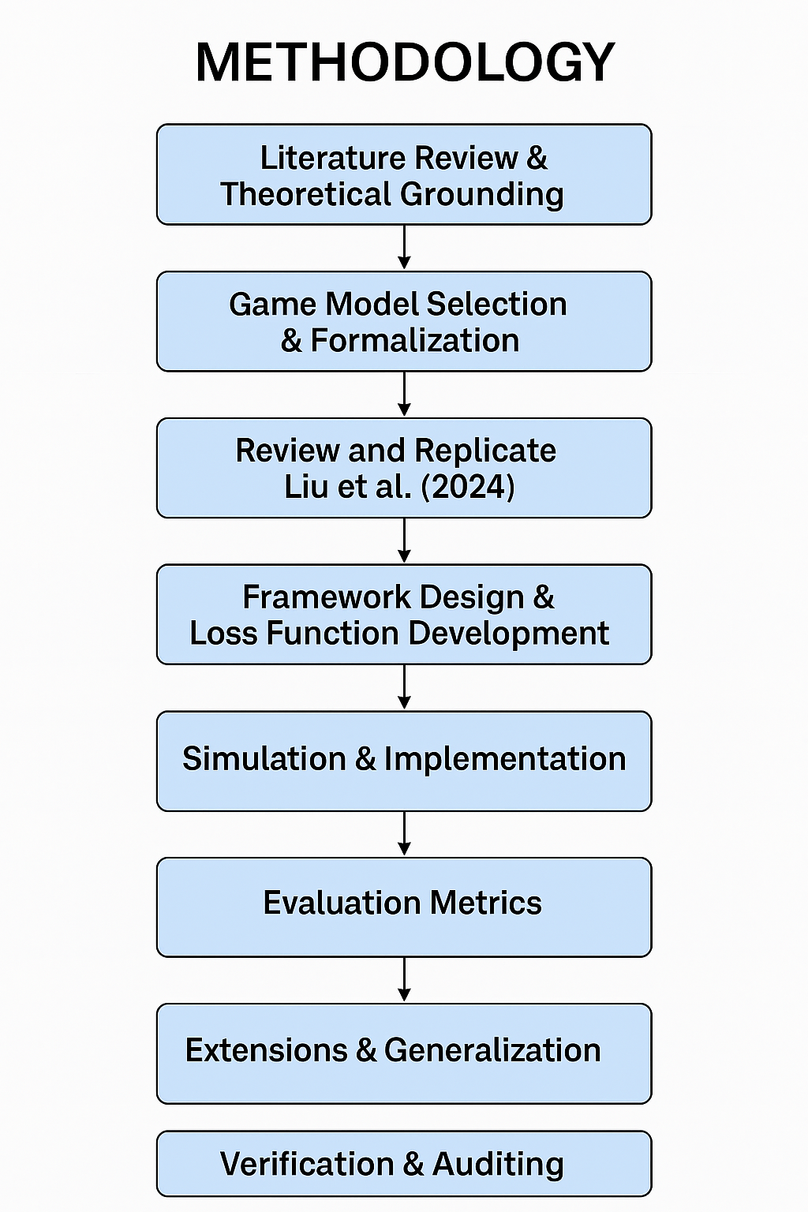

1. Literature Review and Theoretical Understanding
Conduct a systematic literature survey on :
- Existing Machine Unlearning techniques (sequential, federated, dynamic, feature unlearning, LLM unlearning, certified removal, SISA , attack patterns)
- Game Theory , understanding the discipline
  - Game Theory applications in privacy, security, machine unlearning
- Deliverable : Getting good theoretical grasp on the core topics, and developing intuition on possible game theory application in machine unlearning.
2. Game Model Design
- Define players:
  - Model provider (utility maximization, performance).
  - Data provider (privacy, fairness, transparency).
  - Adversary (membership inference, reconstruction, poisoning).
- Define strategy sets:
  - Model provider: retraining, partial unlearning, feature-based unlearning.
  - Data provider: full deletion, selective deletion, federated removal.
  - Adversary: membership inference, attribute inference, reconstruction.
- Define utility functions:
  - Accuracy, computational cost, privacy leakage risk, fairness metrics.
- Select suitable game models:
  - Stackelberg (sequential leader–follower).
  - Bayesian (uncertainty in adversary knowledge).
  - Dynamic games (streaming/federated settings).
  - other game models
- Deliverable : Work on Mathematical formulation of payoff functions and equilibrium conditions.
3. Framework Design & Loss Function Development
- Extend Liu et al. (2024) [21] by integrating:
  - Already Implemented
    - Utility module: loss = model distance + classification error.
    - Privacy module: loss = attacker’s advantage (membership inference success probability).
  - This study will first reproduce their methodology and results to establish a validated baseline. Following replication, the research will critically analyze limitations (e.g., reliance on membership inference only, scalability to larger models, sensitivity to dataset choice). Building on this review, the work will then explore extensions such as:
• Incorporating broader attack models (attribute inference, reconstruction, poisoning).
• Adapting the framework to federated and dynamic unlearning settings.
• Extending utility functions to include fairness and transparency metrics.
• Scaling the approach to large language models (LLMs) and high-parameter deep networks.
- Explore applicability and Extend to Fairness, Security, Transparency
- Incorporate additional attack models (attribute inference, poisoning).
- Explore feature-aware strategies: weight contributions of features to utility vs privacy.
  - Extend to SISA model Bourtoule et al., 2020 [20]
- Deliverable: Generalized loss functions + equilibrium analysis proofs.
4. Simulation & Implementation
- Datasets: Adult (tabular), CIFAR-10/MNIST (vision), text datasets, later extend to
- LLM fine-tuning corpora.
- Models: MLP, CNN, ResNet, transformer-based models for LLM pilot.
- Tools: Python, PyTorch/TensorFlow, MLPro-GT for game simulation.
- Steps:
  - Train baseline models.
  - Apply unlearning requests (sample-level, class-level, federated).
  - Implement game-theoretic unlearning algorithm.
  - Train adversary models (membership inference, attribute inference).
  - Evaluate equilibrium outcomes (accuracy vs privacy leakage).
- Deliverable: Experimental results with reproducible code.
5. Evaluation Metrics
- Utility: Accuracy, F1 score, computational overhead.
- Privacy: Membership inference attack success rate, privacy attack advantage.
- Fairness: Bias metrics (optional extension).
- Efficiency: Time vs retraining baseline.
- Deliverable: Comparative tables + plots showing trade-offs.
6. Extensions & Generalization
- Apply framework to:
  - Federated unlearning (multi-agent setting).
  - Dynamic/streaming unlearning (time-evolving data).
  - LLMs (parameter-efficient fine-tuning unlearning).
  - Feature Unlearning
  - Human-in-the-loop
- Explore incentive mechanisms: game-theoretic strategies to encourage data sharing while preserving privacy.
- Deliverable: Extended models + unified framework proposal.
7. Verification & Auditing
- Integrate certified removal checks.
- Use differential privacy bounds to validate leakage reduction.
- Deliverable: Verification protocol + audit framework.
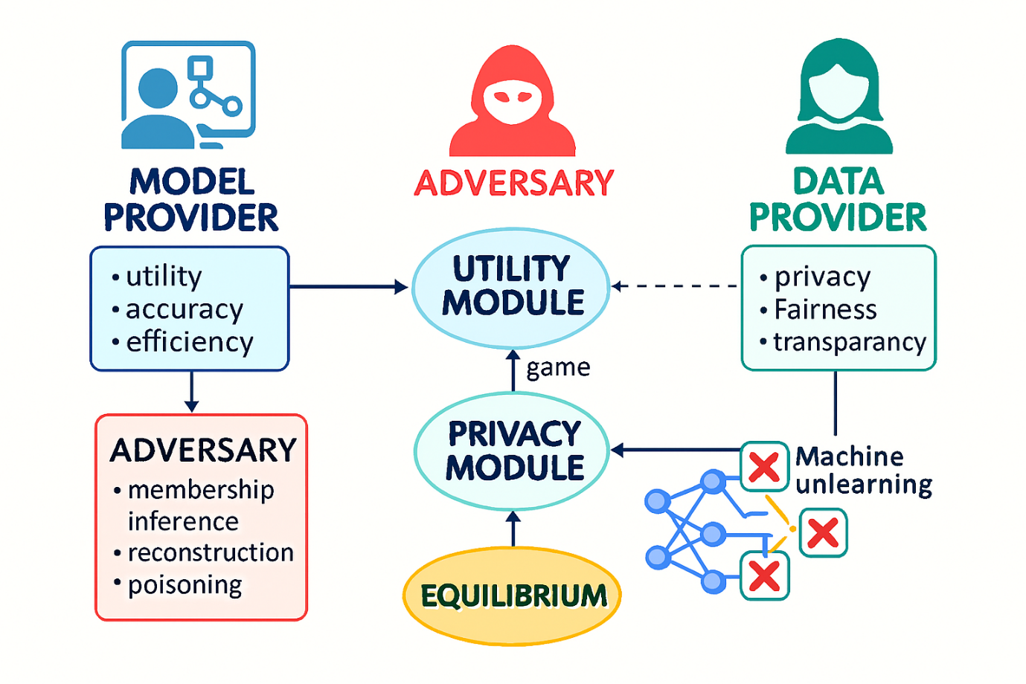

Expected outcome
- A formalized game model, Identify formalized game models strategies, scenario’s, agents applicability , benefits of potentially a multi-stage Stackelberg or static Bayesian game (or other strategies) , describing the strategic interactions and optimization between a model provider and a data provider in machine unlearning. This will help model providers in decision making to achieve compliance in faster and effective way.
- Understand the dynamics that exist in Machine Unlearning between different players like data provider (single or multiple as in federated setting), model provider, how their strategies will change based on the task objective (fairness, privacy, transparency, security) on different settings like dynamic unlearning, sequential unlearning, catastrophic unlearning, federated unlearning, reinforcement unlearning. Develop framework that suggests the most effective and efficient way to achieving equilibrium among players in the game , the strategy to be followed and how to implement it.
- Derived equilibrium strategies that illustrate optimal trade-offs between model accuracy and privacy protection, considering varying unlearning costs and privacy sensitivities.
- Quantifiable results showing the effectiveness of the game-theoretic approach in reducing privacy leakage (e.g., lower membership inference attack success rates after unlearning) while maintaining competitive model accuracy.
- Empowering Data Providers: Data providers (users) will be empowered with a better understanding of the dynamics involved in unlearning, enabling them to make more informed decisions about their data and privacy requests, and to assess the effectiveness of unlearning services.

Importance of proposed research investigation and mention the link to relevant SDG
Proposed research is in one of the leading topics in AI & M L industry – Responsible AI, contributing to building resilient systems, promoting inclusive & responsibility in latest innovations in Generative AI systems SDG 9.
The entire Responsible AI – Machine Unlearning concept stands on the pillars of Privacy-preserving AI at its core, ensuring lesser conflicts & chaos and justice & legal recourse to individuals right to privacy SDG 16.
This research fosters partnership between industry and academia experts by providing a platform for them to contributing equally based on there diverse experience in Responsible AI policies and implementations SDG 17.
Aim to create relevant and relevant learning outcome not only for the researcher but the research outcome will also provide lifelong learning to other students and a useful resource for other researchers working in the same domain SDG 4.
For making AI driven systems accountable we are working on implementation of “right to be forgotten” in efficient and effective way essential for designing sustainable AI systems in production SDG 12.

Research Time plan
Research Activity (TEMPLATE-to be edited as per the requirement) |  | Time ( from Registration) in Months
 |  | 06 | 12 | 18 | 24 | 30 | 36 | 42 | 48 | 54
Course Work
Literature Survey
Methodology Step 1
Methodology Step 2
Methodology Step 3
Methodology Step 4
DAC presentation and registration renewal
Conference presentations |  |  |  |  | C |  | C
Journal Publications |  |  |  |  |  | J |  | J
Preparation of Final Thesis
Synopsis presentation
Submission of Thesis
Part-time candidates - 4 years 6 months (54 months)

S. No. | Title of Paper | Authors / Year | Key Methodology Implemented | Tools / Frameworks Used | Key Findings / Observations | Relevance to Proposed Research
1 | Membership Inference via Backdooring (MIB) | Hu et al., 2022 | Membership inference using backdoor triggers and hypothesis testing | Python, PyTorch; CIFAR-10, Purchase-100, Location-30 datasets | Demonstrated that marking only 0.1% of data enables effective membership inference with statistical guarantees; ASR thresholds validated | Provides a detection mechanism for unauthorized data usage, an essential precursor to unlearning
2 | Machine Unlearning (SISA Training) | Bourtoule et al., 2020 | Sharded, Isolated, Sliced, Aggregated training for efficient unlearning | Python, TensorFlow; Purchase dataset, SVHN, ImageNet | Achieved 4.63× speed-up in unlearning compared to retraining from scratch, with minimal accuracy degradation | Establishes a scalable baseline for unlearning, which can be extended with game-theoretic strategies
3 | MLPro-GT-game theory and dynamic games modeling in Python | Steve Yuwono ∗, Detlef Arend, Andreas Schwung | Modular, Object-oriented classes for game theory implementation (players, strategies, payoffs, training etc.) | Python, MLPro | Supports dynamic game modelling, with inbuild support for strategies (Prisoner’s Dilemma, Rock-Paper-Scissors, Supply & Demand, Routing with Congestion). | Understand game theory implementation , opportunity to use and expand on existing framework.
4 | Game-Theoretic Machine Unlearning: Mitigating  Extra Privacy Leakage | Hengzhu Liu, Tianqing Zhu, Lefeng Zhang, Ping Xiong∗ | Stackelberg competition between unlearning performance and privacy protection ,loss function (model distance + classification error) | Models: MLP, CNN  Datasets: text dataset Adult, Image datasets MNIST,CIFAR10(DenseNet,ResNet) | Trade-off between utility and privacy to ensure effective machine unlearning and maintain excellent model performance | The paper directly validates the application of game theoretic framework, which will be used as building block for our research

9. Pilot study / Preliminary work done
The pilot study was undertaken to understand the feasibility of Machine Unlearning with Game Theory frameworks. Since, the implementation of both are very few and not readily available. We tried to focus our pilot study in understanding existing machine unlearning and how it has potential for strategic interactions. Also, for better understanding of game theory for implementation purposes we studied code implementation. We are also tried to gain information on the datasets and experimental setups done, also we tried to analyze how game theory framework can be applied to machine unlearning by understanding and implementing existing papers.

Papers Implemented :
The SISA model is very useful technique which helps to understand the basic principles of machine unlearning, it’s basic idea is very simple, but it also help us understand the overall challenges possible, we were able to implement it while we observed some code fixes were necessary. I see potential of game theory based strategic interactions in SISA , I propose to explore and implement feature based game theory framework interactions and also analyze which game theory frameworks could be applicable.
Other paper is based on MIA, understanding the factors leading to successful MIA and possible mitigation methods can actually help the players in choosing the right strategy in the game. I would like to deep dive on designing strategy game to reduce chances of successful MIA in existing Machine Unlearning algorithms including SISA and others.
For real world application going beyond theory , will need to implement our theoretical models and derive conclusion – MLPro-GT helps us by giving a reference to use or build on it, though it’s existing use case has been limited to basic cases and not complex, it can be stepping stone to implement our logic and expand on its existing implementation.
For “ Game-Theoretic Machine Unlearning: Mitigating Extra Privacy Leakage” diagrams hows the scope and

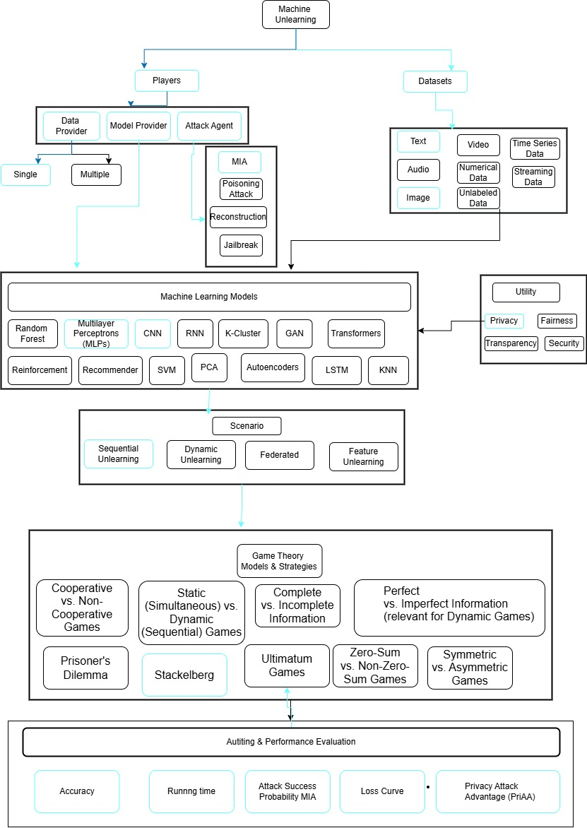
implemented (SISA: Sharded, Isolated, Sliced, Aggregated training)

1) Accuracy vs Requests (one line per shard count)
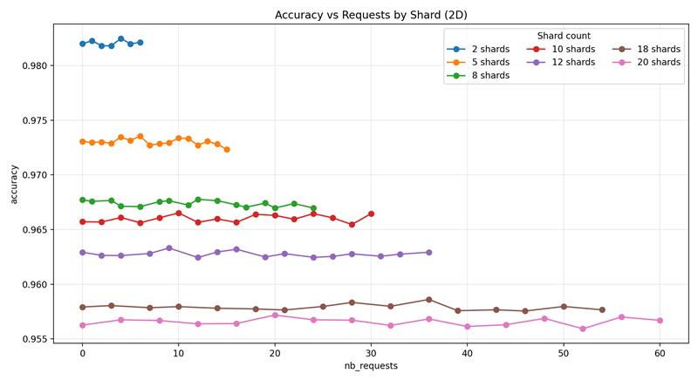
Accuracy is primarily separated by shard count (higher at low S; lower at high S). Within each shard, accuracy is relatively stable across requests.

2) 2D Facets: Retraining Time vs Requests
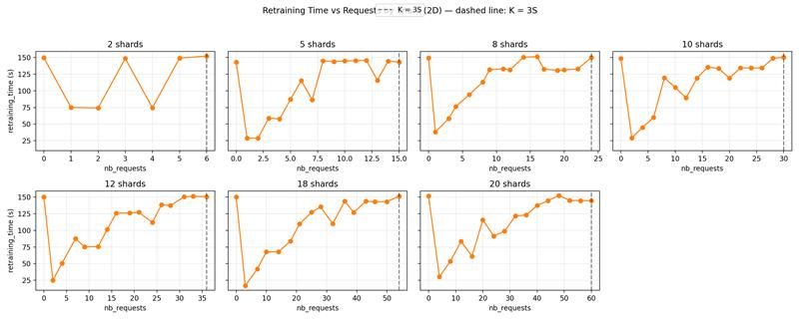
Retraining time grows with requests.

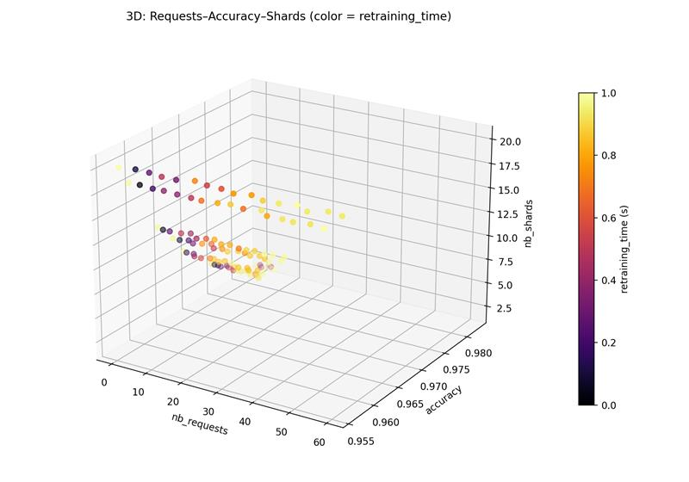
3) Requests × Accuracy × Shards; color = Retraining Time
Lower shards → higher accuracy but often longer retraining time (brighter colors).
- Higher shards → lower accuracy but retraining tends to cluster lower/steadier.
This is the central accuracy–time trade-off expected from SISA sharding.

4) Requests × Retraining Time × Shards; color = Accuracy
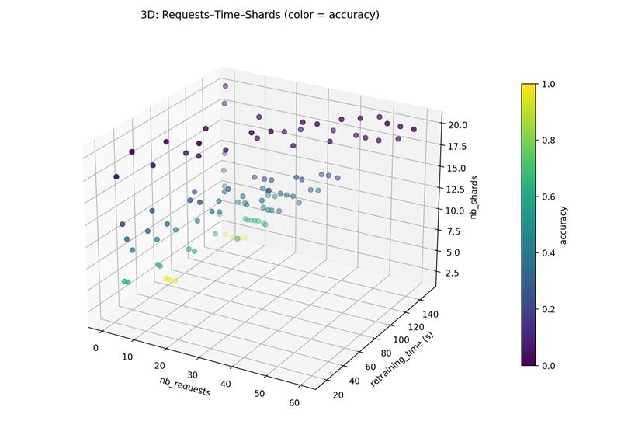
Flips the view to make the time scaling with requests front-and-center while showing the accuracy color band decreasing with larger shard counts.

5) (heatmaps): Shards × Requests with color = Retraining Time and Accuracy
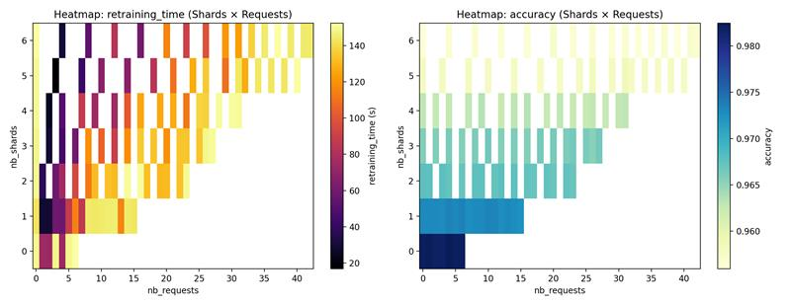

- Retraining time heat is highest at small S and grows with requests.
- Accuracy heat is highest at small S and drops as S increases.
Both are expected: sharding partitions data, producing “weaker” constituents at high S (lower accuracy) but cheaper unlearning (smaller retraining sets).

6) Trade-off: Accuracy vs Retraining Time (color by shard count)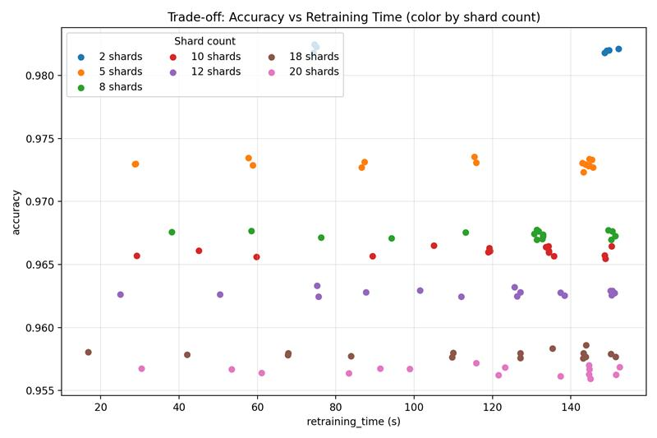
A clear Pareto-like front—moving to fewer shards pushes accuracy up at the cost of time; moving to more shards reduces time at the cost of accuracy. This matches SISA’s central trade-off.

🔎 How results align with the SISA paper (quick mapping)
- Why accuracy drops as shard count increases
SISA isolates training per shard; each constituent sees less data, which can create weak learners and reduce aggregate accuracy as S grows—especially for more complex tasks. Your plots show a clean monotonic decline of accuracy with S.
- Why retraining gets cheaper as shards increase
For one request, retraining is confined to the affected shard; expected cost scales with shard size (~N/S). Hence higher S reduces retraining cost/time—exactly what your time curves show.
- Threshold on number of requests (K) vs shards (S)
The paper notes sharding’s benefits are most pronounced while K is not too large relative to S, with a practical boundary often discussed around K ≲ 3S; beyond that, overall savings degrade toward the baseline. The dashed lines at K=3S in the facet chart make that region explicit for your data.
- Slicing (R) and its effect
Although your dataset doesn’t include slices R, SISA’s slicing stores pre-slice checkpoints so retraining restarts from the last slice before the forgotten point—cutting retraining. Best-case sequential speed-up from slicing alone approaches 1.5×, and combined with sharding reaches ≈(R+1)·S/2 for a single request. If you log R and checkpoints next time, we can visualize that speed-up too.
- Aggregation
At inference, SISA aggregates shard-models (e.g., majority vote or averaging prediction vectors). On simple tasks, strategy changes matter little; on complex tasks, averaging prediction vectors helps recover accuracy—consistent with the paper’s observations. Your accuracy separation by S is fully consistent with this aggregation-driven ensemble behavior.
- Time proxy—why plotting “retraining_time” makes sense
The paper validates that training time is ~linear in #samples retrained, so your measured retraining_time is the right metric to read scaling effects.

🧠 Takeaways from implementation
- Choose S to sit on your accuracy–time Pareto:
  - S=2–5 → highest accuracy, costlier unlearning.
  - S=8–12 → balanced.
  - S=18–20 → lowest unlearning time, noticeable accuracy hit.
This mirrors SISA’s guidance that increasing S increases speed-up but can reduce accuracy; staying in a regime with K ≲ 3S preserves the speed-up advantage. [kr-prod.as…rosoft.com]
- If also implement slicing (R), will compound speed-ups. Capture and log:
  - #slices R, slice size, where each forget event lands (slice index),
  - checkpoint sizes/times,
and we’ll add slice-aware 4D/5D plots and quantify the R-dependent speed-up per the paper’s formulas.
- For complex tasks, consider prediction-vector averaging (instead of hard voting) to recover accuracy at higher S.

🔹 Conclusion
The pilot study confirms the feasibility of integrating Game Theory into Machine Unlearning.
  - Current unlearning methods focus on efficiency but ignore strategic interactions (e.g., balancing user privacy demands vs. provider resource costs).
  - Game Theory can formalize these negotiations, ensuring fairness and incentive compatibility.

Details of expenses and source of funding (detailed break-up of research related expenses for consumables/software/equipment/travel etc. to be given along with details of source of funding. If the study does not require funding, same to be mentioned with justification. Scholarships/fellowships awarded to the candidate should NOT be mentioned under research related expenses mentioned above.
Not Applicable

References:
Vancouver

Course work details suggested by DAC with credits
Serial No. | Course (description) name | Credits
1. | Research Methodology | 4
2. | RPE (Research & Publication Ethic) | 2
3. | Responsible AI | 2
4. | Game Theory | 2
5. | Machine Learning | 2

Similarity check report having total word count, index < 15% and exclude Matches<3 duly signed by the candidate and guide.


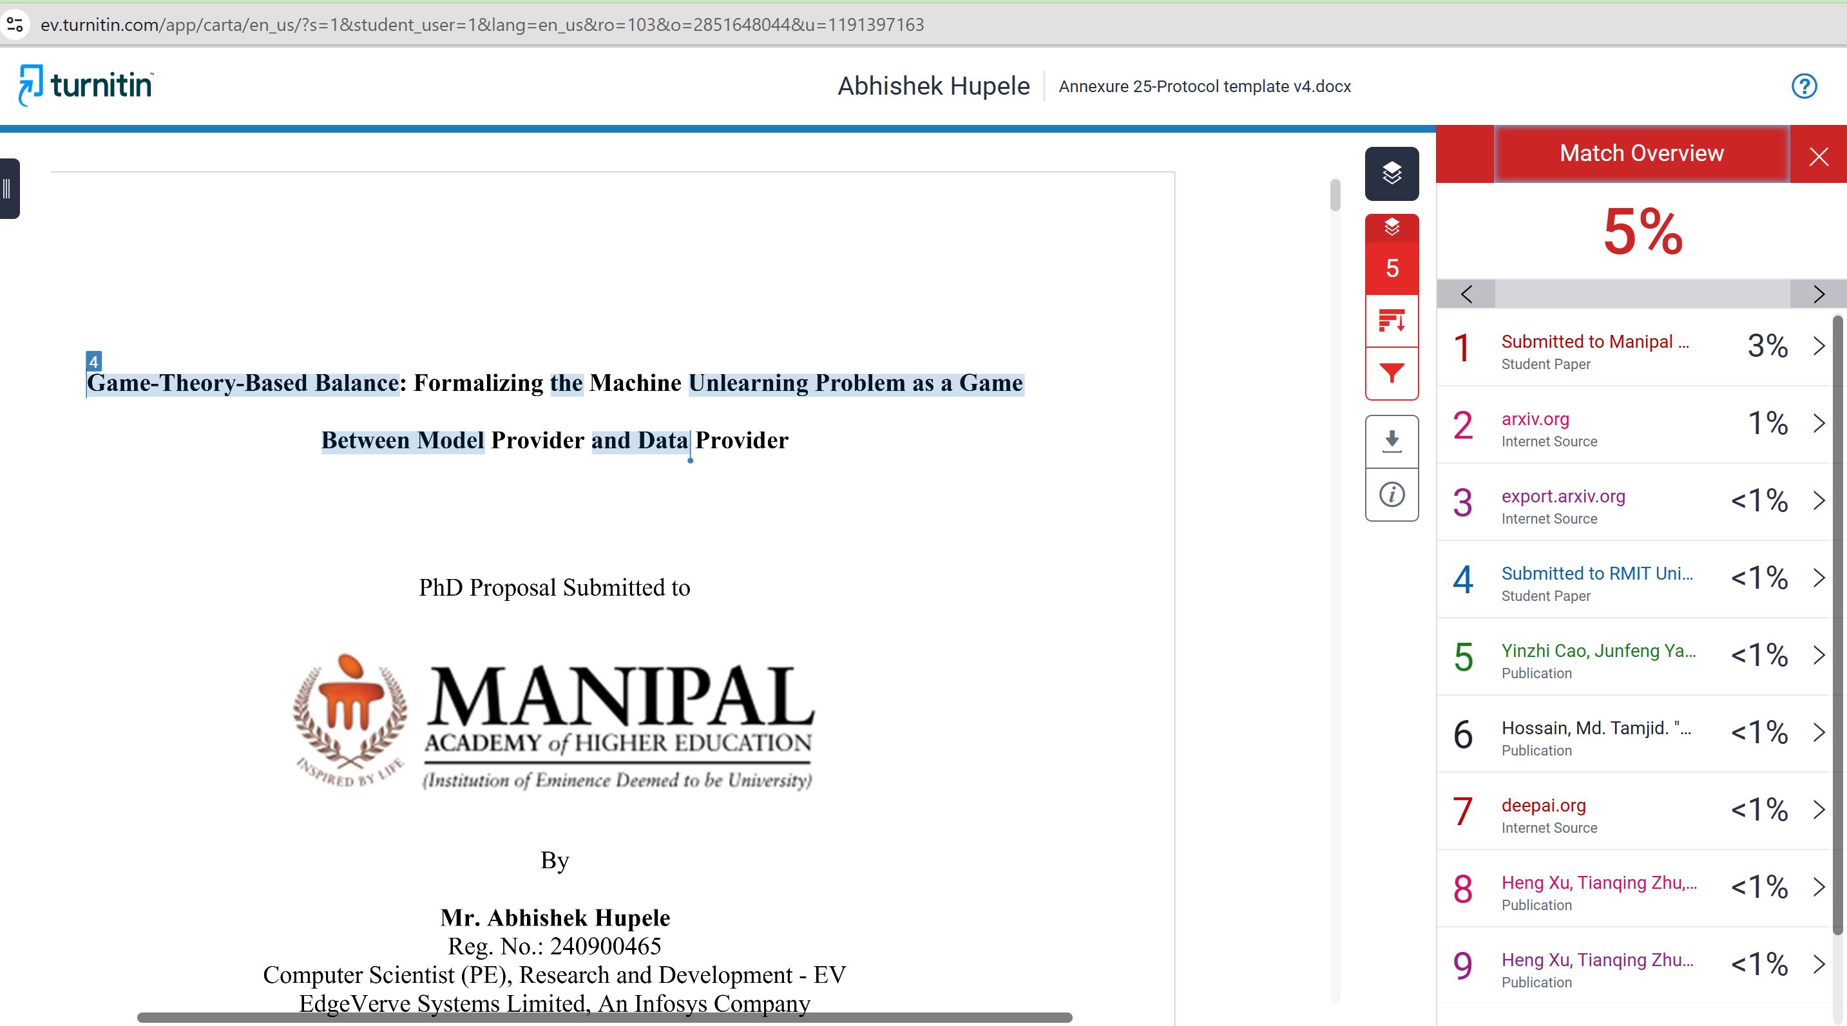

Appendix (References)
[1] Machine Unlearning: A Survey HENG XU, TIANQING ZHU, and LEFENG ZHANG, University of Technology Sydney, Australia WANLEI ZHOU, City University of Macau, China PHILIP S. YU, University of Illinois at Chicago, United States
[2] Machine Unlearning: A Comprehensive Survey WEIQI WANG, University of Technology Sydney, Australia ZHIYI TIAN, University of Technology Sydney, Australia CHENHAN ZHANG, University of Technology Sydney, Australia SHUI YU, University of Technology Sydney, Australia
[3] Stefanos Leonardos and Georgios Piliouras. 2022. Exploration-exploitation in multi-agent learning: Catastrophe theory meets game theory. Artif. Intell. 304 (2022), 103653. DOI: http://dx.doi.org/10.1016/j.artint.2021.103653
[4] Lei Cui, Youyang Qu, Mohammad Reza Nosouhi, Shui Yu, Jianwei Niu, and Gang Xie. 2019. Improving data utility through game theory in personalized differential privacy. J. Comput. Sci. Technol. 34, 2 (2019), 272–286. DOI:http: //dx.doi.org/10.1007/s11390-019-1910-3
[5] Xueqin Liang, Zheng Yan, Robert H. Deng, and Qinghua Zheng. 2021. Investigating the adoption of hybrid encrypted cloud data deduplication with game theory. IEEE Trans. Parallel Distrib. Syst. 32, 3 (2021), 587–600. DOI:http://dx.doi. org/10.1109/TPDS.2020.3028685
[6] Jiahui Geng, Qing Li, Herbert Woisetschlaeger, Zongxiong Chen, Fengyu Cai, Yuxia Wang, Preslav Nakov, Hans-Arno Jacobsen, Fakhri Karray A Comprehensive Survey of Machine Unlearning Techniques for Large Language Models DOI: https://doi.org/10.48550/arXiv.2503.01854
[7] Exploring Federated Unlearning: Review, Comparison, and Insights Yang Zhao, Member, IEEE, Jiaxi Yang, Student Member, IEEE, Yiling Tao, Student Member, IEEE, Lixu Wang, Student Member, IEEE, Xiaoxiao Li, Member, IEEE, Dusit Niyato, Fellow, IEEE, and H. Vincent Poor, Life Fellow, IEEE
[8] Chuan Guo, Tom Goldstein, Awni Y. Hannun, and Laurens van der Maaten. 2020. Certified data removal from machine learning models. In 37th International Conference on Machine Learning (Proceedings of Machine Learning Research, Vol. 119). PMLR, 3832–3842. Retrieved from http://proceedings.mlr.press/v119/guo20c.html.
[9] Reinforcement Unlearning Dayong Ye∗ , Tianqing Zhu† , Congcong Zhu† , Derui Wang‡ , Kun Gao∗ , Zewei Shi‡ , Sheng Shen, Wanlei Zhou† , and Minhui Xue‡ ∗University of Technology Sydney, †City University of Macau, ‡CSIRO’s Data61, Torrens University Australia, https://arxiv.org/pdf/2312.15910
[10] Xiaofeng Ding, Hongbiao Fang, Zhilin Zhang, Kim-Kwang Raymond Choo, and Hai Jin. 2022. Privacy-preserving feature extraction via adversarial training. IEEE Trans. Knowl. Data Eng. 34, 4 (2022), 1967–1979. DOI:http://dx.doi. org/10.1109/TKDE.2020.2997604
[11] Bo Zhang, Hancheng Ye, Gang Yu, Bin Wang, Yike Wu, Jiayuan Fan, and Tao Chen. 2022. Sample-centric feature generation for semi-supervised few-shot learning. IEEE Trans. Image Process. 31 (2022), 2309–2320. DOI:http://dx. doi.org/10.1109/TIP.2022.3154938
[12] Jiajing Zhu, Yongguo Liu, Chuanbiao Wen, and Xindong Wu. 2022. DGDFS: Dependence Guided Discriminative Feature Selection for predicting adverse drug-drug interaction. IEEE Trans. Knowl. Data Eng. 34, 1 (2022), 271–285. DOI:http://dx.doi.org/10.1109/TKDE.2020.2978055
[13] [Wu et al., 2023] Xinwei Wu, Junzhuo Li, Minghui Xu, Weilong Dong, Shuangzhi Wu, Chao Bian, and Deyi Xiong. DEPN: Detecting and editing privacy neurons in pretrained language models. In Houda Bouamor, Juan Pino, and Kalika Bali, editors, Proceedings of the 2023 Conference on Empirical Methods in Natural Language Processing, pages 2875–2886, Singapore, December 2023. Association for Computational Linguistics.
[14] [Jia et al., 2024] Jinghan Jia, Jiancheng Liu, Yihua Zhang, Parikshit Ram, Nathalie Baracaldo, and Sijia Liu. WAGLE: Strategic weight attribution for effective and modular unlearning in large language models. In The Thirty-eighth Annual Conf
[15] A Survey on Recommendation Unlearning: Fundamentals, Taxonomy, Evaluation, and Open Questions Yuyuan Li, Xiaohua Feng, Chaochao Chen*, Senior Member, IEEE, and Qiang Yang, Fellow, IEEE
[16] Alessandro Mantelero. The EU proposal for a general data protection regulation and the roots of the ’right to be forgotten’. Comput. Law Secur. Rev., 29(3):229–235, 2013.
[17] O. of the Privacy Commissioner of Canada. Announcement: Privacy commissioner seeks federal court determination on key issue for canadians’ online reputation.
[18] Lydia de la Torre. A guide to the california consumer privacy act of 2018. Available at SSRN 3275571, 2018.
[19] Digital Personal Data Protection Act, 2023. Available at https://www.meity.gov.in/static/uploads/2024/06/2bf1f0e9f04e6fb4f8fef35e82c42aa5.pdf
[20] L. Bourtoule, V. Chandrasekaran, C. A. Choquette-Choo, H. Jia, A. Travers, B. Zhang, D. Lie, and N. Papernot, “Machine unlearning,” in Proc. IEEE Symposium on Security and Privacy (SP), 2021
[21] Hengzhu Liu, Tianqing Zhu, Lefeng Zhang, Ping Xiong, “Game-Theoretic Machine Unlearning: Mitigating Extra Privacy Leakage”, in JOURNAL OF LATEX CLASS FILES, VOL. 14, NO. 8, AUGUST 2021 1
[22] Stuart Wesselby, “Responsible AI: Principles, Practices, and Applications. How to implement ai responsibly”, https://www.udemy.com/course/responsible-ai-principles-practices-and-applications/?srsltid=AfmBOorcJDN91T-1RxFtCerA13W6GAUedvgXI_K5mlDnzcsPdM9ebOlg
[23] Yinzhi Cao and Junfeng Yang. 2015. Towards making systems forget with machine unlearning. In IEEE Symposium
on Security and Privacy. IEEE Computer Society, 463–480. DOI:http://dx.doi.org/10.1109/SP.2015.35
[24] Xiaofeng Ding, Hongbiao Fang, Zhilin Zhang, Kim-Kwang Raymond Choo, and Hai Jin. Privacy-preserving feature extraction via adversarial training. IEEE Trans. Knowl. Data Eng., 34(4):1967–1979, 2022.
[25] Bo Zhang, Hancheng Ye, Gang Yu, Bin Wang, Yike Wu, Jiayuan Fan, and Tao Chen. Sample-centric feature generation for semi-supervised few-shot learning. IEEE Trans. Image Process., 31:2309–2320, 2022.
[26] Jiajing Zhu, Yongguo Liu, Chuanbiao Wen, and Xindong Wu. DGDFS: dependence guided discriminative feature selection for predicting adverse drug-drug interaction. IEEE Trans. Knowl. Data Eng., 34(1):271–285, 2022

15. Appendix (Pilot Study)
nb_shards | nb_requests | accuracy | retraining_time
5 | 0 | 0.973035 | 142.9339
5 | 1 | 0.97297 | 28.73434
5 | 2 | 0.973002 | 28.94636
5 | 3 | 0.972874 | 58.84903
5 | 4 | 0.973452 | 57.69825
5 | 5 | 0.973131 | 87.29315
5 | 6 | 0.973548 | 115.3566
5 | 7 | 0.972714 | 86.56729
5 | 8 | 0.972842 | 144.7681
5 | 9 | 0.972938 | 143.8127
5 | 10 | 0.973356 | 144.7536
5 | 11 | 0.973323 | 145.3513
5 | 12 | 0.972714 | 145.6993
5 | 13 | 0.973067 | 115.8567
5 | 14 | 0.97281 | 144.5557
5 | 15 | 0.972328 | 143.2101
10 | 0 | 0.965715 | 148.6497
10 | 2 | 0.965683 | 29.18924
10 | 4 | 0.966101 | 45.0551
10 | 6 | 0.965619 | 59.73994
10 | 8 | 0.966069 | 119.4192
10 | 10 | 0.966518 | 105.0686
10 | 12 | 0.965651 | 89.39693
10 | 14 | 0.965972 | 118.9083
10 | 16 | 0.965651 | 135.6794
10 | 18 | 0.96639 | 133.6492
10 | 20 | 0.966293 | 119.1694
10 | 22 | 0.96594 | 134.4282
10 | 24 | 0.966454 | 134.3093
10 | 26 | 0.966069 | 134.4094
10 | 28 | 0.965459 | 148.8602
10 | 30 | 0.966454 | 150.4329
10 | 0 | 0.965715 | 148.6497
10 | 2 | 0.965683 | 29.18924
10 | 4 | 0.966101 | 45.0551
10 | 6 | 0.965619 | 59.73994
10 | 8 | 0.966069 | 119.4192
10 | 10 | 0.966518 | 105.0686
10 | 12 | 0.965651 | 89.39693
10 | 14 | 0.965972 | 118.9083
10 | 16 | 0.965651 | 135.6794
10 | 18 | 0.96639 | 133.6492
10 | 20 | 0.966293 | 119.1694
10 | 22 | 0.96594 | 134.4282
10 | 24 | 0.966454 | 134.3093
10 | 26 | 0.966069 | 134.4094
10 | 28 | 0.965459 | 148.8602
10 | 30 | 0.966454 | 150.4329
20 | 0 | 0.956263 | 151.5105
20 | 4 | 0.956744 | 30.35683
20 | 8 | 0.95668 | 53.44075
20 | 12 | 0.956375 | 83.35944
20 | 16 | 0.956407 | 61.05139
20 | 20 | 0.957178 | 115.856
20 | 24 | 0.956744 | 91.30537
20 | 28 | 0.956712 | 98.90384
20 | 32 | 0.956231 | 121.5417
20 | 36 | 0.956825 | 123.199
20 | 40 | 0.956134 | 137.3811
20 | 44 | 0.956295 | 144.6223
20 | 48 | 0.956873 | 152.4814
20 | 52 | 0.955926 | 145.0179
20 | 56 | 0.957001 | 144.6763
20 | 60 | 0.956696 | 144.7018
2 | 0 | 0.981992 | 149.7914
2 | 0 | 0.981992 | 149.7914
2 | 0 | 0.981992 | 149.7914
2 | 1 | 0.982264 | 75.00028
2 | 1 | 0.982264 | 75.00028
2 | 2 | 0.981799 | 74.26386
2 | 2 | 0.981799 | 74.26386
2 | 2 | 0.981799 | 74.26386
2 | 3 | 0.981799 | 148.66
2 | 3 | 0.981799 | 148.66
2 | 4 | 0.982473 | 74.53041
2 | 4 | 0.982473 | 74.53041
2 | 4 | 0.982473 | 74.53041
2 | 5 | 0.981975 | 149.1944
2 | 5 | 0.981975 | 149.1944
2 | 6 | 0.98212 | 152.1951
8 | 0 | 0.967707 | 149.5675
8 | 1 | 0.967578 | 38.12246
8 | 3 | 0.967659 | 58.45889
8 | 4 | 0.967129 | 76.27075
8 | 6 | 0.967097 | 94.21215
8 | 8 | 0.967546 | 113.1748
8 | 9 | 0.967626 | 131.7506
8 | 11 | 0.967241 | 132.9425
8 | 12 | 0.967755 | 131.31
8 | 14 | 0.967643 | 150.6325
8 | 16 | 0.967257 | 151.3201
8 | 17 | 0.967033 | 132.7266
8 | 19 | 0.967418 | 130.6816
8 | 20 | 0.966968 | 131.3296
8 | 22 | 0.96737 | 132.8882
8 | 24 | 0.966968 | 150.3129
12 | 0 | 0.962924 | 150.1711
12 | 2 | 0.962635 | 24.98882
12 | 4 | 0.962619 | 50.46515
12 | 7 | 0.962811 | 87.6994
12 | 9 | 0.963309 | 75.26012
12 | 12 | 0.962442 | 75.59196
12 | 14 | 0.96294 | 101.516
12 | 16 | 0.963197 | 125.6131
12 | 19 | 0.96249 | 126.2549
12 | 21 | 0.962795 | 127.1139
12 | 24 | 0.962458 | 112.0554
12 | 26 | 0.962539 | 138.4277
12 | 28 | 0.962779 | 137.396
12 | 31 | 0.962555 | 150.3922
12 | 33 | 0.962747 | 151.1637
12 | 36 | 0.962924 | 150.5898
18 | 0 | 0.957916 | 150.2152
18 | 3 | 0.958044 | 16.76322
18 | 7 | 0.957852 | 42.05535
18 | 10 | 0.957948 | 67.81958
18 | 14 | 0.957804 | 67.735
18 | 18 | 0.957739 | 83.86029
18 | 21 | 0.957643 | 109.6746
18 | 25 | 0.957964 | 127.1464
18 | 28 | 0.958333 | 135.3654
18 | 32 | 0.95798 | 110.0109
18 | 36 | 0.958606 | 143.9381
18 | 39 | 0.957579 | 127.1028
18 | 43 | 0.957659 | 143.8166
18 | 46 | 0.957547 | 143.1055
18 | 50 | 0.957964 | 143.2091
18 | 54 | 0.957659 | 151.4314

🧪 Experimental Protocol
Step 1: Baseline Model Training
- Train a standard deep neural network on the Purchase dataset (no sharding/slicing).
- Record:
  - Training time
  - Test accuracy
  - Model size

Step 2: SISA Model Training
- Partition the dataset into shards (start with 20).
- Within each shard, divide into slices (start with 50).
- Train constituent models on each shard with slicing checkpoints.
- Aggregate predictions (majority vote).
- Record:
  - Training time
  - Test accuracy
  - Storage overhead (due to slicing checkpoints)

Step 3: Single Unlearning Request
- Select one random data point to unlearn.
- Retrain baseline model from scratch without that point.
- Retrain only the affected shard/slice in SISA.
- Record:
  - Time to unlearn
  - Accuracy after unlearning
  - Speed-up factor (baseline vs. SISA)

Step 4: Multiple Unlearning Requests
- Issue unlearning requests for 5, 10, and 20 points.
- Compare:
  - Time per request
  - Aggregate accuracy after each batch
- Plot speed-up vs. number of requests.

Step 5: Shard Sensitivity
- Repeat Step 2 with different shard counts (10, 20, 50).
- For each configuration, measure:
  - Accuracy
  - Unlearning time
- Plot accuracy vs. shard count and speed-up vs. shard count.

Step 6: Slice Sensitivity
- Repeat Step 2 with different slice counts (10, 20, 50).
- For each configuration, measure:
  - Accuracy
  - Storage overhead
  - Unlearning speed
- Plot accuracy vs. slice count and speed-up vs. slice count.

Step 7: Sequential vs. Batched Unlearning
- Issue 10 unlearning requests sequentially (one by one).
- Issue 10 unlearning requests in a batch (all at once).
- Compare:
  - Average time per request
  - Accuracy degradation
- Plot time vs. request mode (sequential vs. batched).

Step 8 (Optional): Distribution-Aware Unlearning
- Simulate non-uniform requests (e.g., 30% of requests come from one subgroup).
- Place those points strategically in shards.
- Measure expected unlearning time vs. uniform distribution.

📊 Data to Collect
- Accuracy before/after unlearning
- Time per unlearning request
- Speed-up factor (baseline vs. SISA)
- Accuracy degradation vs. shards/slices
- Storage overhead due to slicing
- Sequential vs. batched efficiency

✅ Pilot Study Scope
- Stick to Purchase dataset only.
- Run Steps 1–7 as your core experiments.
- Step 8 is optional if you want to extend beyond the paper

